SCUBA-2 Block Specification
fsfb_corr

Created on: 7 October 2005
Last saved on: 07 October 2005
Table of Contents

1. Block Description 3
1.1 Block Hierarchy 3
1.2 Block Overview and Features 3
1.3 Detailed Description 3
2. Interface Description 4
2.1 Signals Description 4
2.2 Protocol / Interface Timing 5
3. Dataflow Description 6
4. State Machine Description 7
4.1 FSM 1 7
4.2 FSM 2 7
Source Files 8

Block Description

Block Hierarchy
[insert block diagram of hierarchy here, grey out all blocks except the block this document describes]

Block Overview and Features
[describe in brief]

Detailed Description
[describe high-level functionality of module here]

Interface Description

Signals Description
 | Description | Direction
Global Signals
(Other signals 1)
(Other signals 2)

Protocol / Interface Timing
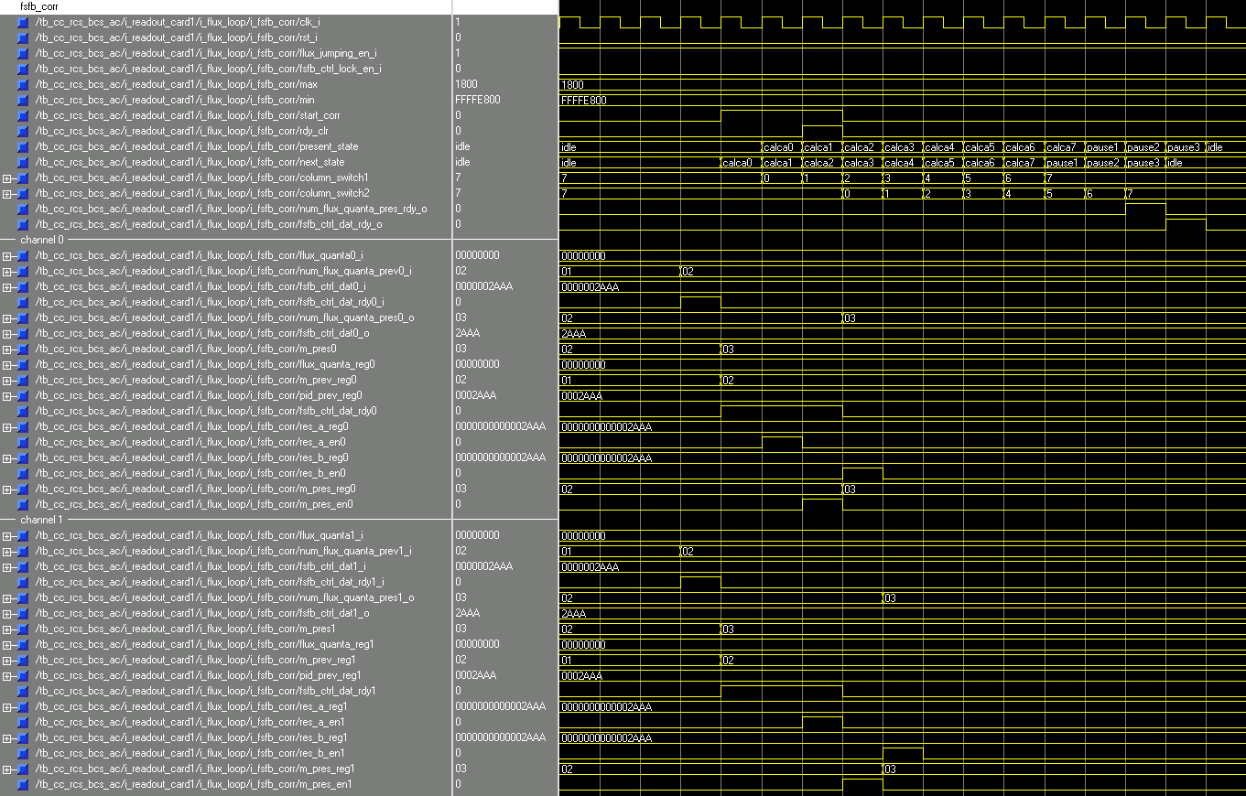

Dataflow Description

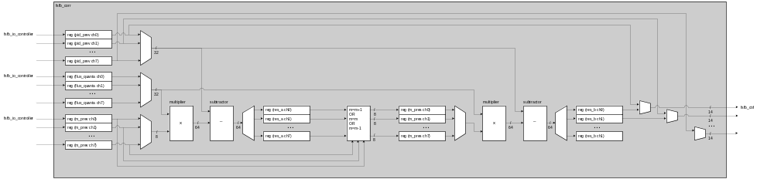

State Machine Description

FSM 1
[insert ASM chart here]

FSM 2
[insert ASM chart here]

Files Associated with this Block

File | Description
[list all files that belong to this module] | [and enter a short description beside each]

